COP 3337 Assignment 1

# Problem 1

* Syntax error
  + An error that is due to code structure problems.
  + For example, missing a semicolon at the end of a line would produce a syntax error.
* Runtime error
  + An error that happens when code is running and something impossible to execute is reached.
  + Dividing by zero would cause a runtime error.
* Logic error
  + The program runs when there is a logic error; however, it does not work as intended due to a coder’s fault.
  + A very common logic error is using integer division when it is intended to use floating point division. The mathematical answer to the problem 3/2 is 1.5, but in C++, this operation yields 1 because the division is with integers.

# Problem 2

* 56 % 6 = 2
* 2 + 78 % 4 = 4
* (34 % 5) / 3 = 1
* 2 * 5 / 5 + 3 - 34 % 15 = 1
* 5 % ((13 % 12) – 1) = DIVIDE BY 0 ERROR

# Problem 3











# Problem 4

# Problem 5

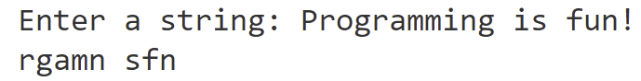



# Problem 6

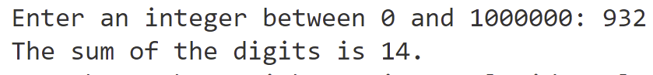



# Bonus

